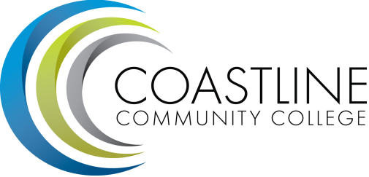

Classified Senate Meeting Agenda
Thursday, October 16, 2014
10AM-12PM
4th floor conference room, College Center

Approval of Minutes (5 minutes):

Fundraising Update (10 minutes):
  - Thirty One Gifts
  - Fall (Halloween) Festival
  - Paints Uncorked

The Great Shakeout (45 minutes):

Committee Reports (10 minutes):

Hot Topics (10 minutes):

Next Meeting: November 20, 2014

